Please note: Always follow the vehicle manufacturers specific ADAS test, measurement, operation and calibration set-up instructions.
ADAS preliminary and supporting information for Adaptive Cruise Control (ACC).
Working with Lasers - radiation class 2.
When working with laser equipment of class 2 always observe the following:
- All work with class 2 laser devices may only be performed by persons who have been instructed about the correct behaviour.
- If the laser beam is in the working area, the laser area must be clearly marked.
- Always wear laser protection glasses when working with lasers.
- Avoid direct eye contact with the laser beam in any case.
- Prolonged viewing (> 0,25 s) may lead to retinal damages.
- Always heed and comply with specific regulations and legislation.
- The manufacturers instructions for safe operation of the laser device should always be observed.
STAGE 1 – Measurement Area
Measurement Area Setup: | CHECK
The maximum unevenness of the standing surface for the adjuster is 1 mm.
The maximum unevenness of the vehicle standing surface is 10 mm.
Viewed from the adjuster, the vehicle standing surface may slope downwards by max. 3 ° or upwards by max. 1 °.
The entire size of the working area should be 360 cm x 700 cm.
An area with a width of at least 80 cm must be available for foot traffic behind the calibration boards.
An appropriate level of workshop lighting is present. No reflection from sunshine or other sources of external lighting should affect the calibration area.

STAGE 2 – Parking and securing the vehicle
Parking and securing vehicles for repair purposes. | CHECK
Vehicles and trailers which do not have to be raised for repair purposes, must be parked on a suitable flat surface.
The parking-brake system must be applied to stop the vehicle rolling away.
On vehicles with Automatic transmissions, the selector lever must be set to P.
If the above action cannot be achieved due to the nature of the repair work, the vehicle must be prevented from rolling by blocking at least two wheels with suitable wheel chocks.
Suitable action must be taken to prevent unintentional start-up of the vehicle (Start-stop systems or Hybrid vehicles).

STAGE 3 – Battery Support
Vehicle battery support during system test and adjustment: | CHECK
Extensive system checks, tests and calibrations whilst the ignition switched on and the engine stopped discharge the component vehicles 12 V Battery. This may result in incorrect system functions, biased measured values, problems with the tester or termination of the system test.
The vehicle electrical system must be supplied with voltage and current using a suitable battery support unit.
Excessively high charging voltages and currents should be avoided, otherwise component damage may result.
Interference or superimposition may occur when checking signals with the battery support active. The battery support unit must be switched off temporarily during signal checks.
When checking voltage, the measured value may be biased if the battery support unit is connected. The battery support unit must be switched off during any voltage tests.
For vehicles that are fitted with electronic battery management systems, special attention must be paid to the instructions given in the vehicle manual for charging and supporting the 12 V Battery.
Follow any additional information on charging and disconnection/connection of the 12 V Battery.
STAGE 4 – Reason For Calibration
Reason the ACC sensor adjustment is required: | SELECT
Changes were made to the chassis geometry (e.g. changing the vehicle ride height through fitment of modified suspension, fitting of larger alloy wheels, fitting new suspension components, chassis alignment adjustments).
Vehicle body work removal and refitting was performed at the front of the vehicle (e.g. accident damage to the vehicle's front, bumper support removal for timing belt replacement, etc.).
The ACC sensor component has been removed and re-installed.
The ACC sensor component has been replaced.

STAGE 5 – Pre-adjustment requirements (subject to vehicle make and model)
VW Group Pre-adjustment requirements: | CHECK
If a night vision camera is installed, depending on the case of damage, it must be calibrated before the ACC adjustment.
The ACC sensor adjustment should be made directly after the wheel alignment. The running gear should assessed for free-play, wear and damage.
The load status of the vehicle is adjusted according to the same conditions for a wheel alignment check and adjustment. Typical conditions may include:
All fluid levels must be at Maximum.
The spare wheel, jack and tools are present in their intended locations.
The fuel tank must be > 90% full.
The wheel alignment and run-out compensation have been properly implemented. Following a wheel alignment, ensure that the axle parts are free of tension or strain.
The vehicle is properly aligned and the suspension is bounced. The Wheels and the Steering wheel are in the centre position. If the vehicle has Rear axle steering, make sure that it is in the centre position.
A sufficiently large standing surface for the adjustment must be ensured.
The vehicle is secured against rolling away.

STAGE 6A – ACC Pre-calibration checks (subject to vehicle make and model)
VW Group ACC Pre-calibration checks. | CHECK
Ensure that the ACC sensor is clean and undamaged.
Ensure that the ACC sensor fixing bracket is not bent, damaged or otherwise out-of-alignment.
Ensure that the ACC sensor fixing bracket and the attachment points of the sensor and the bracket are intact.
Ensure that no fault memory entry exist in the ACC system or related systems (fault memory entries that are assigned to the calibration of the ACC sensor are acceptable).
For vehicles fitted with Ride Height Level control, depending on the version, the vehicle level specified by the vehicle manufacturer is to be set first corresponding to a wheel alignment and then the Jacking mode should be enabled.
If necessary, allow vehicles with Ride Height Level control (such as Air or Dynamic Suspension) should be left and allowed to cool down. Further information can be found in the operating instructions of the vehicle manufacturer.
Tread depth per axle may not exceed 2 mm difference (the rolling circumference differences, due to fitment of different brands of tyres on the same axel, should also be considered).
The tyre inflation pressure has been checked in line with the manufacturer's specifications and corrected as appropriate.
The vehicle must not be moved during the entire adjustment procedure.
All doors should be closed.
If the vehicle lighting is switched on, switch it off (light levels can affect the calibration process).

STAGE 6A – ACC Pre-calibration checks (subject to vehicle make and model)
ACC Pre-calibration Checks | CHECK
Great care must be taken when setting the ACC sensor, as very small difference in the sensor setting of > 0,2 ° is sufficient to impair the overall system accuracy and correct functioning.
Depending on the vehicle type and system, a coarse setting (manual basic alignment) of the ACC sensor may have to be performed prior to calibration adjustment.

Calibration Procedure :
Observe and follow safety instructions. Set-up the Measuring Area. Check the pre-adjustment condition have been satisfied.
Perform pre calibration checks.
Connect battery support unit and route the electrical wires so that the ACC sensor is not concealed or obscured.
Connect up the diagnostic test equipment. If a diagnostic connecting cable is present, feed this through an open window.
If fitted, remove the cover from the ACC sensor.
Set the position and location of the calibration board following the manufacturers instructions (e.g. distance from the sensor, parallel to the vehicle, aligned to the vehicles radar/centre line).
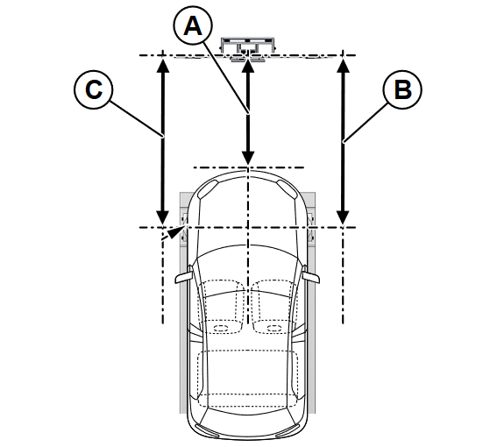 | Dimensions:  A: 120cm (+-2.5cm), measured from reflector plate to face of radar.  B & C: Stage 1 -parallel from wheel to front to beam. Stage 2 - reflected back to laser source.  Values should be equal. Shuffle rig with feet down to achieve parity.  Recheck A after parallel adjustments are completed.
Perform the radars ‘coarse’ mechanical alignment (laser alignment) if applicable.
Set-up the radar reflector according to the manufacturers instructions.
No persons or objects should be allowed between the ACC sensor and the calibration device.
Select the ACC Adjustment in the diagnostic test equipment and follow the prescribed procedure, adjusting the screws and the radar reflector as directed by the test equipment.
Perform the following operations on completion of the function <ACC sensor adjustment>:
Erase fault memory, check the fault memory.
Check warning light function.
Perform a test drive to confirm correct operation of the Adaptive Cruise Control system.
Read out fault memory after the road test.
Create and complete the calibration certificate (use your candidate number as your personal identifier).

Roadtest:
When performing a test drive, it is essential to heed the applicable local road traffic regulations as well as all other relevant laws.
Test drives are only to be performed by people in possession of a valid licence to drive the appropriate vehicle who also fulfil the necessary technical, personal and health requirements.
Test drives on public roads are only permitted using officially licensed vehicles.
Vehicles not officially licensed must be provided with the appropriate temporary licence plates.
Before starting a test drive, make sure the vehicle is in proper working order and in roadworthy condition.
Particular attention must be paid to checking operation of the lighting and indicator systems, as well as ensuring adequate and even braking action on a brake dynamometer.
The test drive must not impair, obstruct or even endanger the traffic on public roads.
For various systems, a certain distance must be covered or a minimum speed exceeded in the test drive for full implementation of system-specific adaption processes, test routines and system adaption functions.

