4 (Criteria 2.2) Levels of current and voltage that present a hazard for both alternating and direct current systems.
The safe voltage is 60 V for direct voltage (DC) and 25 V for AC voltage (AC). The human body reacts differently to these voltages.
The graph below shows the levels of current which present a hazard to human health.

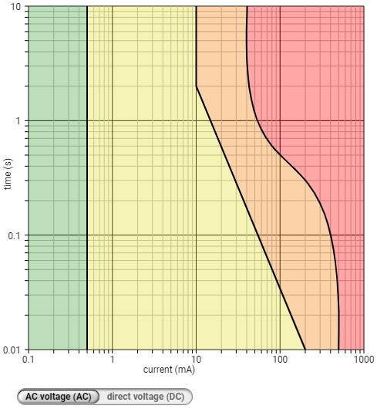 | 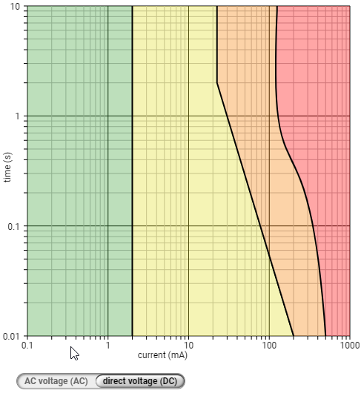
AC Current | DC Current
Chart Key:
Green: not externally noticeable
Yellow: externally noticeable, muscles cramp
Orange: muscle cramps, difficulty breathing, letting go no longer possible
Red: life-threatening, burns, respiratory arrest, cardiac arrest.
(Criteria 2.3) The ‘Stimulus Threshold’ is shown in the yellow zone. This is considered to be the level at which current stimulates the nervous system. Current flow above the level of 16mA is said to be above the ‘Let Go Threshold’; the muscles will cause a person to involuntarily grip. Current flow levels below this are perceptible (can be felt) and the person will still be in control of muscle function. The Maximum Touch Voltage is considered to be 25V AC and 30V DC. Voltage levels above this level require the person to be insulated from the voltage.

(Criteria 2.4) The Stimulus Voltage type will have two different reactions. When applied to the hand, for instance, if a person was to touch a voltage source, the DC voltage will cause a grip action, where as AC Voltage will cause a grip and release action.

