Description:
The SMRs (System Main Relays) are the relays that connect or disconnect the high voltage power system in accordance with commands from the power management control ECU.
There are 3 SMRs and 1 precharge resistor. SMRB, SMRP, SMRG, and the precharge resistor are located in the HV battery junction block assembly in the HV battery pack.
To connect to the high voltage power system, the vehicle will first turn on SMRP and SMRB to charge the vehicle through the system main resistor. Then, SMRP will be turned off after SMRG is turned on. To shut off the high voltage power system, SMRB and SMRG are turned off.
Wiring Diagram:
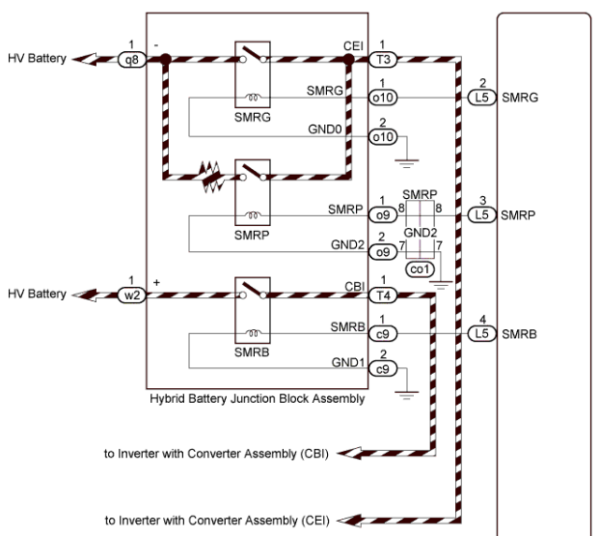

Waveform:
Ch1 Precharge Relay
Ch2 Main Relay
Ch3 HV DC Voltage
Ch4 HV DC Current
