Functional Description:
A resolver is a sensor that is used to detect the position of the magnetic poles the rotor of a motor generator. Knowing the position of the poles is indispensable for ensuring precise control of MG2 and MG1.
Each resolver contains a stator that has an excitation coil and 2 detection coils (S, C). The gap between the stator and rotor changes as the rotor turns because the rotor is oval shaped. An alternating current with a predetermined frequency flows through the excitation coil, and detection coils S and C output alternating currents in accordance with the sensor rotor position.
The inverter with converter assembly (MG ECU) detects the absolute position of the rotor according to the phases of detection coils S and C and the heights of their waveforms. Furthermore, the CPU calculates the amount of change in the position within a predetermined length of time, in order to use the resolver as a speed sensor.
The MG ECU monitors signals output from the motor resolver and detects malfunctions.
Functional Diagram:
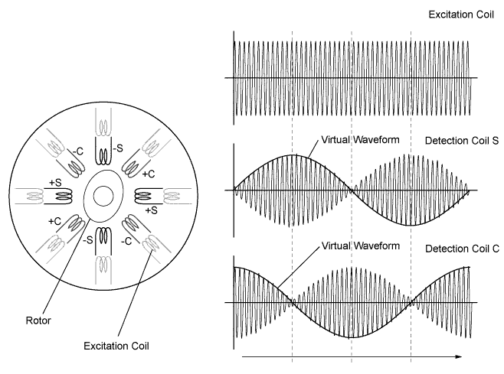

Wiring Diagram:
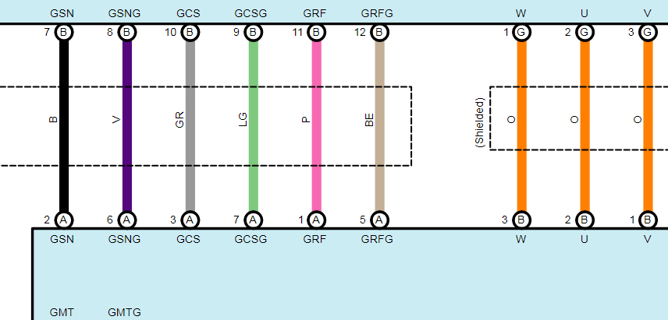

Resolver Waveform:
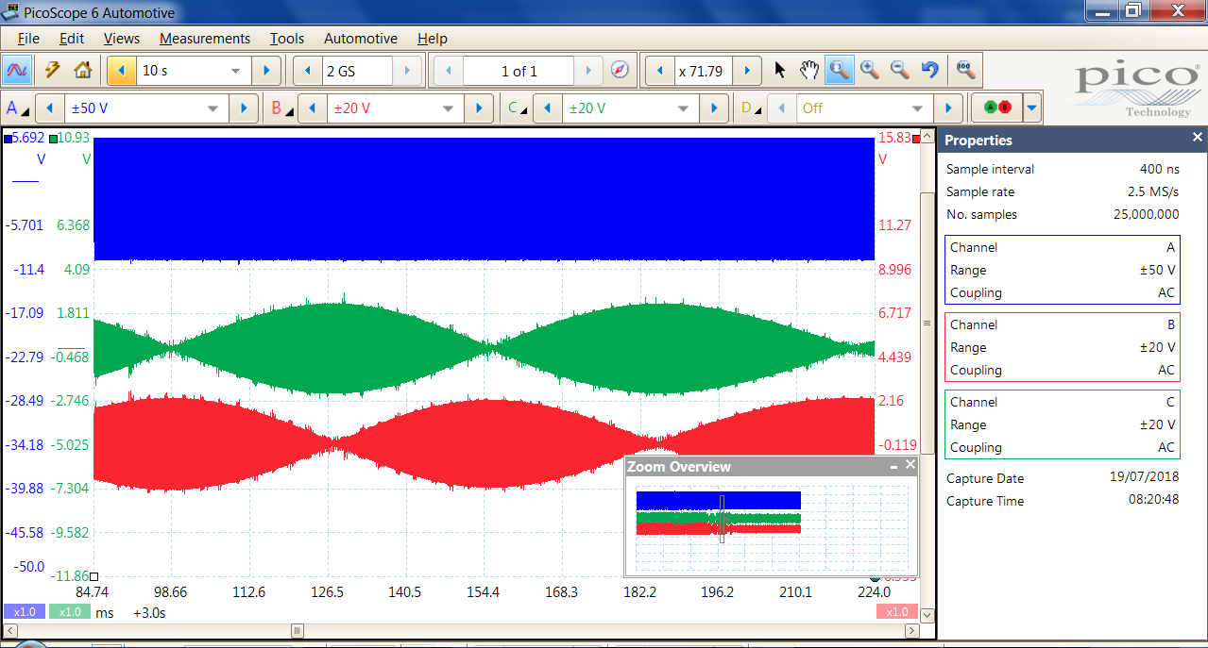
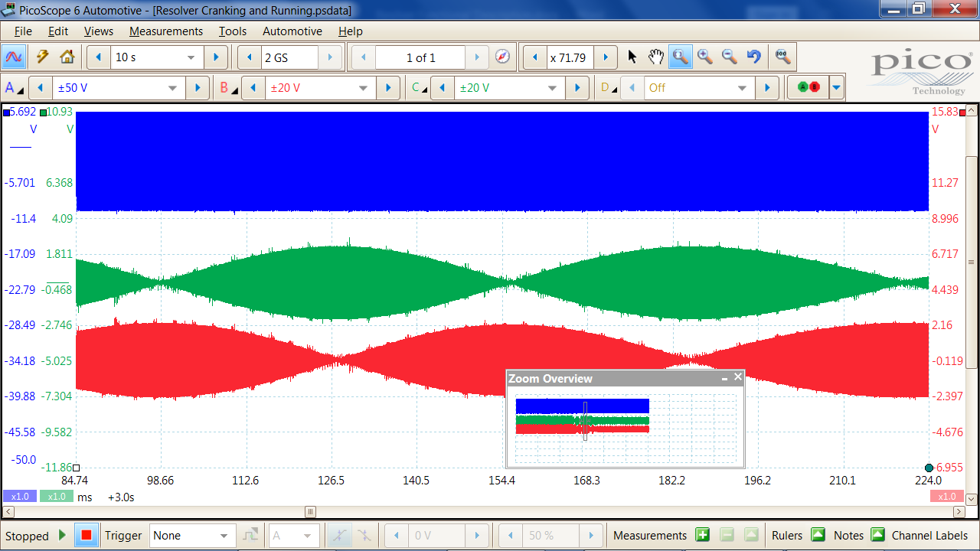
Resolver Engine Running at Idle Speed:
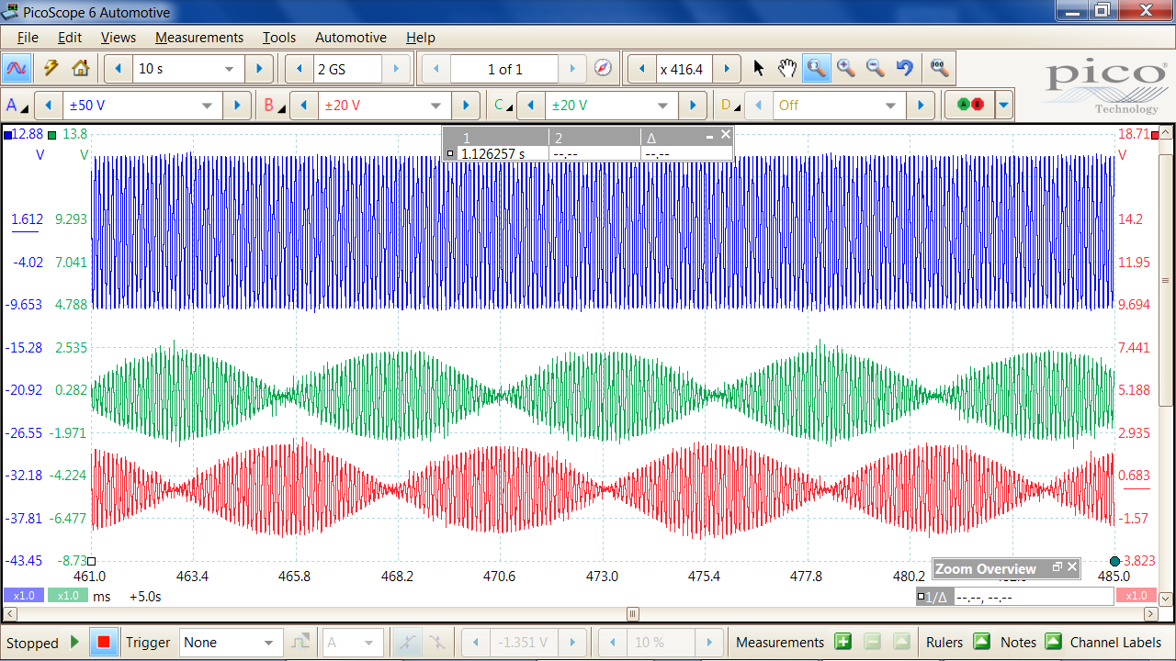

Resolver Engine Slowing Down:
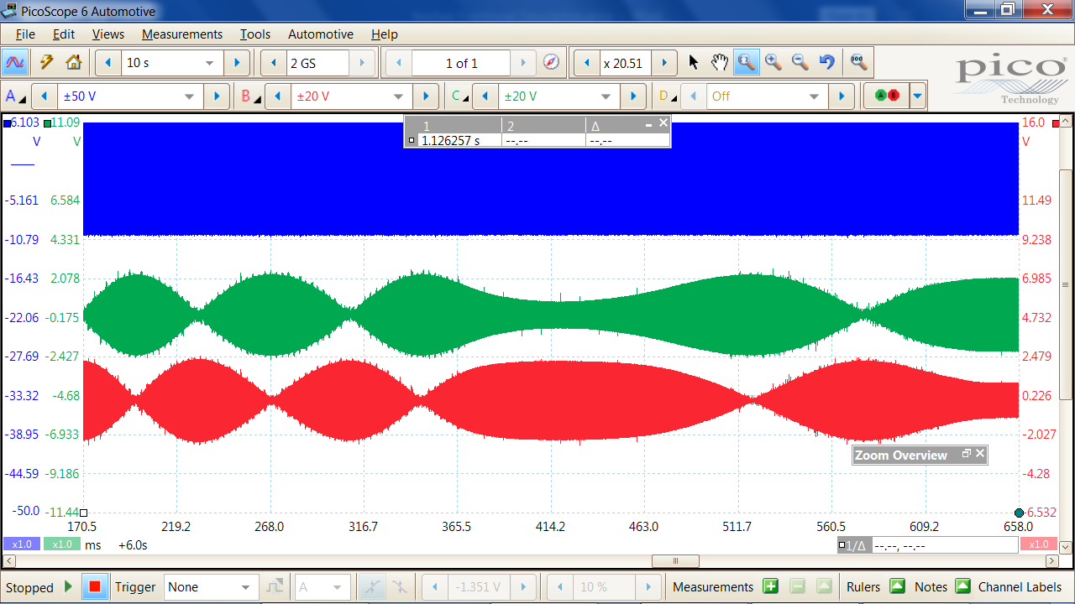
Typical Fault Code for Resolver Position Sensor:
