Functional Description:
The PTC (Positive Temperature Coefficient) heater is installed at the exit or the backside of heater core. The PTC heater is an electric heater using a PTC element as an auxiliary heating device that supplements deficiency of interior heat source in highly effective ICE. The electric heater heats up the interior by directly heating the air that passes through the heater. The name itself implies that the element has a proportional resistance change sensitive to temperature.
ECM outputs a PTC ON signal and operates PTC relay 1. Then heater controller operates PTC relay 2 and PTC relay 3 with an interval of 15 seconds. However, PTC relay 3 can be operated while battery voltage is above 12.4V.
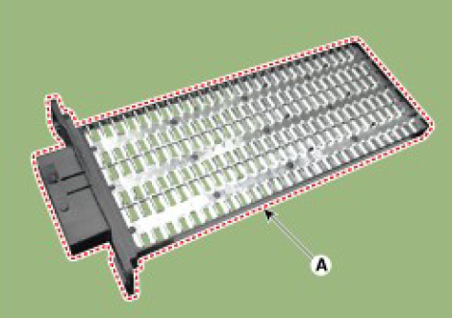
Ambient Temp | Coolant Temp | PTC Operation
Below -20 deg C | Below 75 deg C | ON
10 deg C | Below 65 deg C | ON
12 deg C or above |  | OFF
 | 80 deg C or above | OFF
Functional Diagram:
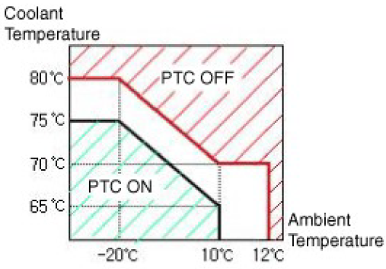

Testing:
Test mode. Inspect the PTC operation by confirmation logic as follows.
1. Entering
(1) Set the Floor mode and maximum heating position.
(2) Turn off the blower switch.
(3) Press the intake (recirculation) button 5 times or more.
(4) Indicators of intake and A/C button are continuously flashed with an interval of 0.5 seconds.
(5) Confirm the PTC operation by turn on the blower switch.
(6) Each PTC relay is operated with an interval of 3 seconds.
(7) The logic test will be automatically cancelled after 30 seconds.
In addition, it can be cancelled by followings.
• Select A/C or intake (recirculation) switch
• Ignition switch OFF
Test Specification:
Operation | Current (A)
PTC 1 ON | 0.1 to 33A
PTC 2 ON | 0.1 to 33A
PTC 3 ON | 0.1 to 33A
TOTAL | 0.1 to 100A

Wiring:
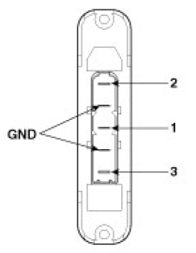 |  | 