Description:
When the power management control ECU detects that a safety device is operated, it will prohibit hybrid system operation or shut off the system main relay. There are three safety devices in three different locations. The first safety device is located at the service plug grip. The second one is located at the frame wire that is connected to the inverter with converter assembly. The third one is located at the inverter cover where the motor and generator cables and No. 2 engine wire (air conditioning harness) are connected to the inverter with converter assembly. If the service plug grip, inverter cover, or frame wire is removed, the interlock signal line will be open. If the vehicle is being driven, this condition will be determined to be an open circuit and the system main relays will not be shut off. If the safety devices are re-installed correctly, the system will return to normal when the power switch is turned on (IG).

DTC Table:
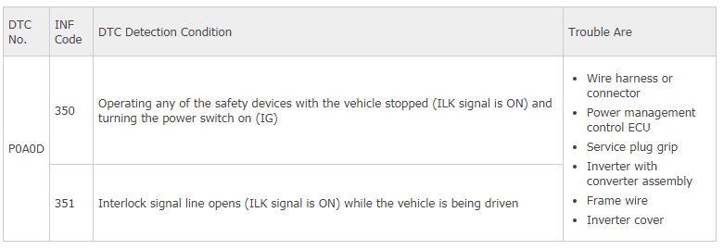
Wiring Diagram.
