Description:
After turning the power switch off, the plugin charge control ECU assembly transmits a charge start request signal to the Charging Circuit Interrupting Device (CCID) and electric vehicle charger assembly after connecting the charging cable (electric vehicle charger cable assembly) to the charge inlet (electric vehicle charger cable assembly).
The plugin charge control ECU assembly receives charge enable signals from the CCID and electric vehicle charger assembly and drives the electric vehicle charger assembly, charge relay, SMR, DC-DC converter and charges the HV battery pack with HV battery voltage that has been boosted by the electric vehicle charger assembly.
For Waveform Initial Description (Check Notes P116 for waveform Description)
Block Diagram:
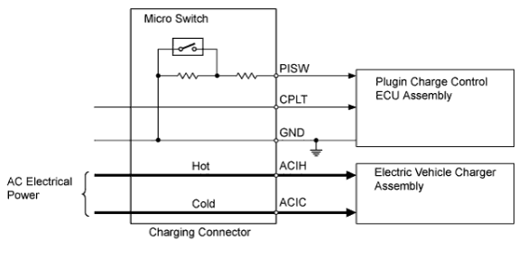
Control | Outline
Charging Control | The plugin charge control ECU assembly controls charging to either normal charging (maximum power) or slow charging (lower power) according to the State Of Charge of the HV battery. Normal charging is performed first, then, when the HV battery State Of Charge is nearing the fully charged state, the ECU assembly switches to slow charging.
AC Input Control | The plugin charge control ECU assembly detects the allowable current value via the CPLT signals and transmits the AC input current restriction value request signal (ILMT) to the electric vehicle charger.
Auxiliary Control | When charging, the auxiliary battery voltage is lowered to the limit of the control range (13.5 V) in order to reduce the current applied to the accessories and auxiliary battery.
Charging Timer Function | The electric vehicle charge is controlled to start supplying power from the external outlet at the start time set using the charging timer switch (satellite switch set) or to complete charging at the set finish time.
Remote Air Conditioning Control | - The plugin charge control ECU assembly receives remote air conditioning signals from the power management control ECU. If the SOC is above a predetermined level, the plugin charge control ECU assembly transmits an output power signal to the electric vehicle charger assembly based on the AC input voltage signals.  - The electric vehicle charger assembly receives this signal and supplies power to the A/C inverter.

Waveform:
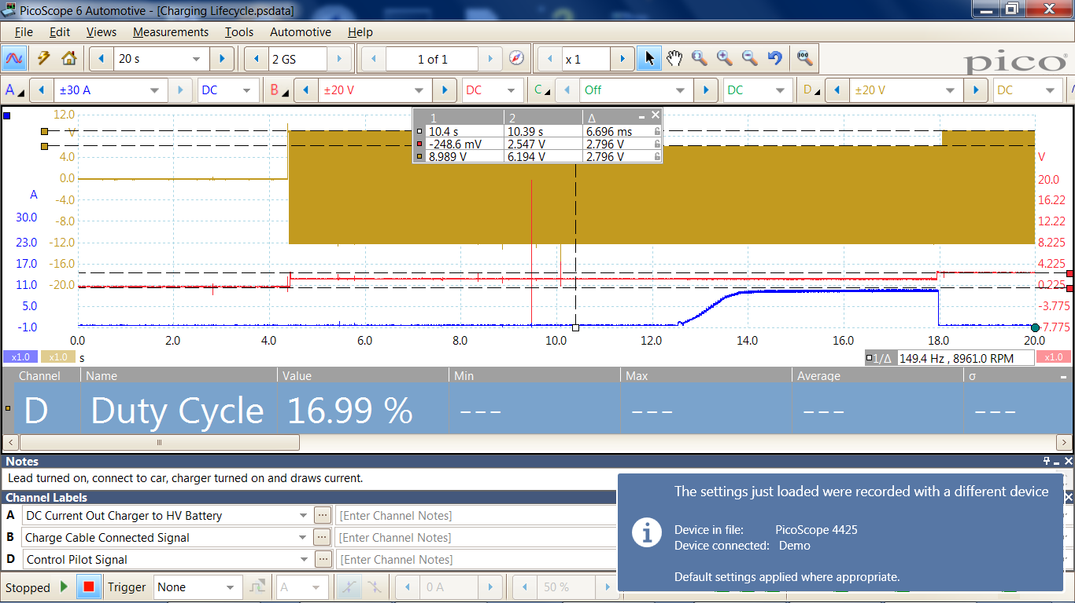
Waveform Description:
